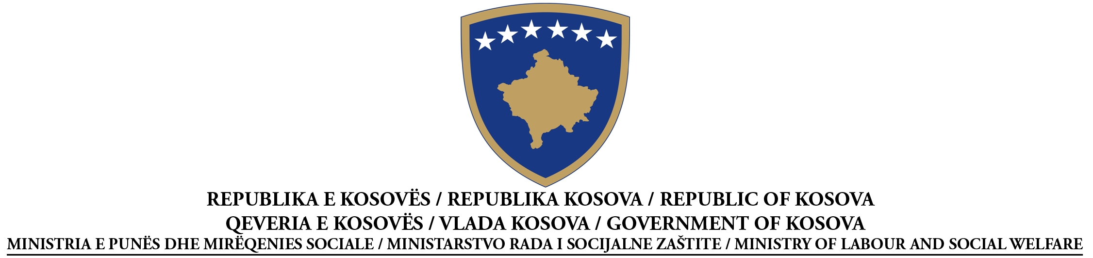

CONTRACT AWARD NOTICE
SERVICES
(Unit expedited procedure)
Re-announcement)
According to Section 40.3 of Law No. 02/L-99, Law on Public Procurement in Kosovo, promulgated with
Regulation No.2007/20
Procurement No: 209/11/015/211
I: CONTRACTING AUTHORITY: Ministry of Labour and Social Welfare, Str.”UÇK”no.1,Prishtina
II: OBJECT OF THE CONTRACT
II.1.1 Contract title attributed by the contracting authority: Physically security of MLSW Facilities with regional expansion
III.1 TYPE OF PROCEDURE
X Open Restricted Negotiated
III.2: CONTRACT AWARD CRITERIAS: Lowest price.
IV: CONTRACT AWARD
(In case of some parts given to some successful economic operators, repeat S.IV.4 and IV.5 for each lot)
IV.4 Name and addresses of economic operator to whom the contract has awarded:
”Syri Group” Adress: St.”Isa Kastrati”, Prishtina
IV.5 Information on value of contract
Total final value of contract: annual 144,144.00€ (including VAT)
V.1 COMPLAINTS
Any interested party may file a complaint to the Procurement Review Body,
(address): _____ str.”Garibaldi”, n.n, Prishtina ________________________,
According to the provisions of Title VIII of Law No 02/L -99, Law on Public Procurement in Kosovo, promulgated with Regulation 2007/20.
Full version of the contract award notice is available at: www.ks-gov.net/krpp

