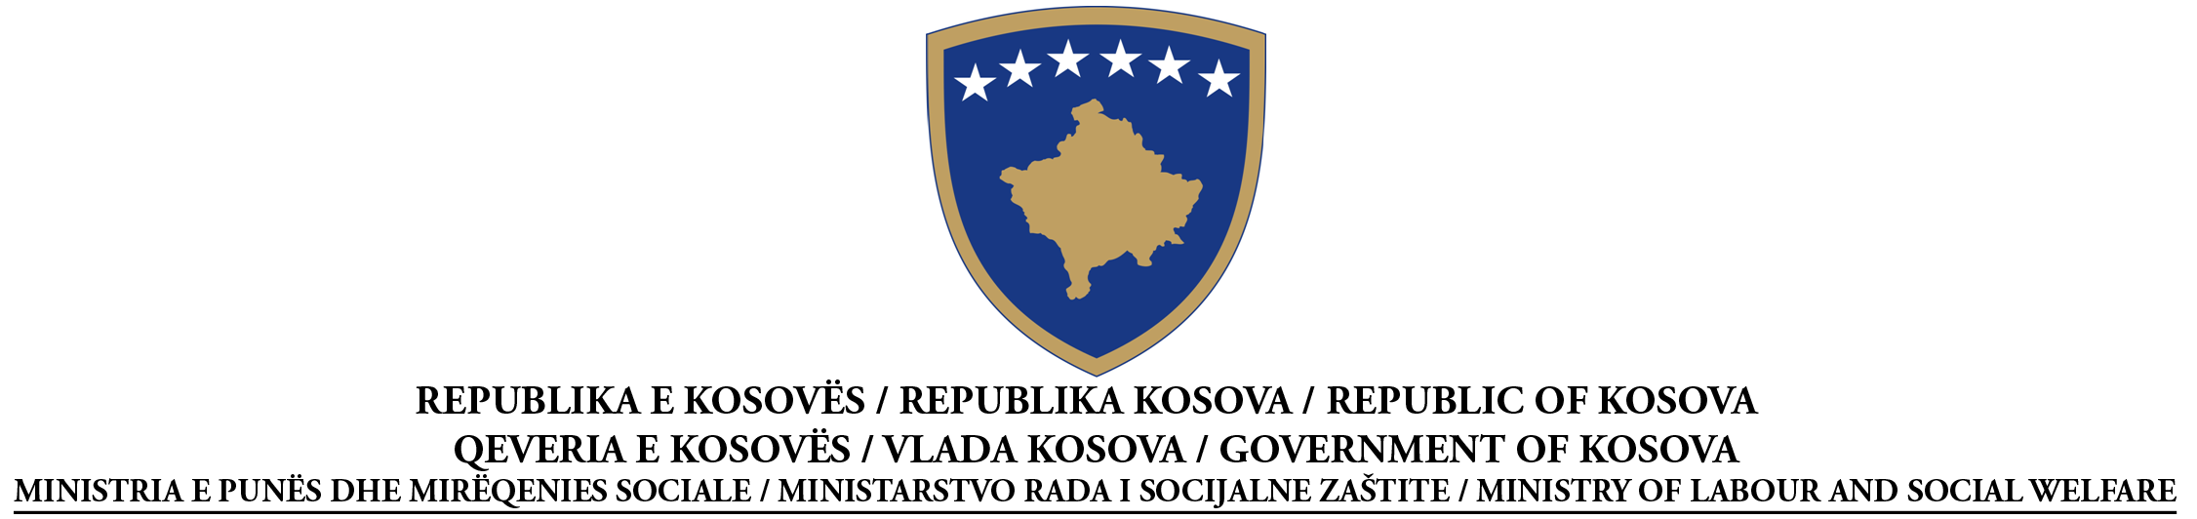

CONTRACT AWARD NOTICE
With an economic operator
Services
Open Procedure

According to Article 41 of Law No. 04/L-042 on Public Procurement in Kosovo

Date of the preparation of the Notice: 28/05/2015

Procurement No | 209 | 14 | 024 | 211

This notice has been prepared in the LANGUAGES:
Albanian |  | Serbian |  | English

SECTION I: CONTRACTING AUTHORITY

I.1) NAME AND ADDRESS OF THE CONTRACTING AUTHORITY (CA)
Official name: Ministry of Labour and Social Welfare
Postal address: Str: ‘’UCK”, No.1
Town: Prishtina | Postal code: 10 000 |  | Country: Kosova
Contact point(s): Azemine Reçica |  | Telephone: 038 211-041
Email: Azemine.recica@rks-gov.net |  | Fax: 038 212 895
Internet address (if applicable):

Yes |  | No
The contracting authority is purchasing on behalf of other contracting authorities

SECTION II: OBJECT OF THE CONTRACT

II.1) DESCRIPTION
II.1.1) Contract title attributed by the contracting authority:
“" Supply with expendable material for office."Llot-1

II.1.2) Type of contract and location of works, place of delivery or of performance
(Choose one category only - works, supplies or services - which corresponds to the main part of the specific object of your contract)
Works | Supplies | Services
Execution  Design and execution  Realisation, by whatever means, of work, corresponding to the requirements | Purchase  Lease  Rental  Hire purchase  A combination of these
Main site or location of works  _______________________________________________ | Main place of delivery  ____________________________________________ | Main place of performance
II.1.3) The notice involves, if applicable

The conclusion of a framework agreement with single operator

The conclusion of a framework agreement with several operators

Duration of framework agreement: in months ________
II.1.4) Short description of the object of the contract
____“" Supply with expendable material for office."Llot-1
II.1.5) Common Procurement Vocabulary classification (CPV)
28.00.00.00-3

SECTION III: PROCEDURE

III.1) TYPE OF PROCEDURE

Open Restricted Negotiated Price Quotation

III.2) AWARD CRITERIA
Lowest price
or
The most economically advantageous tender in terms of:
Sub-criteria | Weighting in % | Sub-criteria | Weighting in %
1) |  | 5)
2) |  | 6)
3) |  | 7)
4) |  | 8)

III.3) ADMINISTRATIVE INFORMATION
III.3.1) Previous publications concerning the same contract
Prior Indicative Notice: _X_____________________________________
Contract Notice: ____X_______________________________
Other publications (if applicable): ______________________________

SECTION IV: AWARD OF CONTRACT
(In case of some parts given to some successful economic operators, repeat S IV.4 and IV.5 for each lot)
 | IV.1) Date of contract award: 28.05.2015
 | IV.2) Intended date of contract signing: 08.05.2015
 | IV.3) Number of received tenders: 7
 | IV.4) Name and addresses of economic operator to whom the contract has been awarded
Official name: ‘"
Postal address: Adresa Rexhep Mala NR-2, Prishtinë
Town: Prishtina |  | Postal code: 10 000 |  | Country: Kosova
URL (if applicable):
Contact point(s): Drilin Pacarada |  |  | Email:
Telephone: |  |  | Fax:

IV.5) Information on value of contract

Total final value of contract ______: 24,625.47€. ________________
If annual or monthly (please give) number of years __1_ or months ____12___

Responsive tender with lowest price: __ 24,625.47 €. _____
Responsive tender with highest price:_____ 43,333.69 € ________________
IV.6) The contract is likely to be subcontracted
Yes |  | No

If yes, value or proportion of the contract likely to be subcontracted
Value ________________________ ; or Proportion _____ %; Not known yet

Short description of the value/proportion of the contract to be subcontracted (if known)
________________________________________________________________________________
________________________________________________________________________________

SECTION V: COMPLEMENTARY INFORMATION
V.1) COMPLAINTS
Any interested party may file a complaint with the Procurement Review Body, according to the provisions of Title IX of Law No. 04/L-042, Law on Public Procurement in Kosovo.

V.1.1) ADDRESS OF THE PROCUREMENT REVIEW BODY (PRB)
Official name: Public Procurement Body
Address of the PRB: Str, Garibaldi
Town: Prishtina |  | Postal code:
Electronic address (if applicable):
Contact person: | E-mail:
Telephone: | Fax:

V.2) ADDITIONAL INFORMATION

