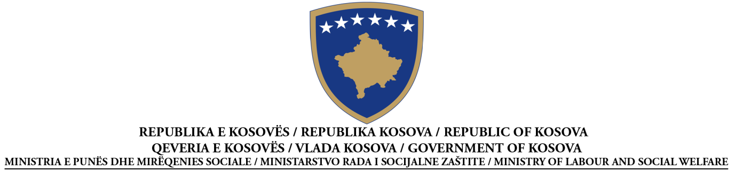

CANCELLATION NOTICE FOR THE PROCUREMENT ACTIVITY
According to Article 62 of Law No. 04/L-042 on Public Procurement in Kosovo

Date of the preparation of the Notice: __15_/04__/2015

Procurement No | 209 | 015 | 004 | 111

This notice has been prepared in the LANGUAGES:
Albanian |  | Serbian |  | English

SECTION I: CONTRACTING AUTHORITY

I.1) NAME AND ADDRESS OF THE CONTRACTING AUTHORITY (CA)
Official name: Ministry of Labour and Social Welfare
Postal address: Street of KLA
Town: Pristine | Postal code: 10 000 |  | Country:
Contact point(s): Azemine Reçica |  | Telephone: : 038/200/26 050 or 200/26/031
Email: Azemine.recica@rks-gov.net |  | Fax: 038/212/831
Internet address (if applicable):

Yes |  | No
The contracting authority is purchasing on behalf of other contracting authorities

SECTION II: OBJECT OF THE CONTRACT

II.1) DESCRIPTION
II.1.1) Contract title attributed by the contracting authority:
__Llot-1, " Supply with expendable material for office "

II.1.2) Type of contract and location of works, place of delivery or of performance
(Choose one category only - works, supplies or services - which corresponds to the main part of the specific object of your contract)
Works | Supplies | Services
Execution  Design and execution  Realisation, by whatever means, of work, corresponding to the requirements | Purchase  Lease  Rental  Hire purchase  A combination of these
Main site or location of works  __________________________________________________ | Main place of delivery  Ministry of Labour and Social Welfare- Regional Centres __________ | Main place of performance
II.1.3) The notice involves

A public contract
Yes |  | No

The establishment of framework agreement
Yes |  | No

II.1.4) Short description of the object of the contract
__________________________________________________________________________________________________________________________________________________________
_____________________________________________________________________________
II.1.5) Common Procurement Vocabulary classification (CPV)
2⁭1⁭0⁭0⁭.0⁭0⁭.0⁭0⁭-3⁭

SECTION III: PROCEDURE

III.1) TYPE OF PROCEDURE

Open Restricted Negotiated

III.2) AWARD CRITERIA
Lowest price
or
The most economically advantageous tender

III.3) ADMINISTRATIVE INFORMATION
III.3.1) Previous publications concerning the same contract
Indicative Notice ________x______________________________
Contract Notice _________x_____________________________
Other publications (if applicable) ______________________________

SECTION IV: CANCELLATION OF PROCEDURE
IV.1) Date of decision on cancellation of procedure__15/04/2015__

IV.2) Number of tenders received ___9__________

IV.3) Reason for cancellation of public procurement procedure

after the opening of tenders

a a violation of the PPL has occurred or will occur in the procurement procedure, which cannot be remedied or prevented through a lawful amendment of the procurement conditions;

a provision in the Public Procurement Law requires the cancellation of the procurement
activity

all responsive tenders contain prices that substantially exceed the contracting authority’s budget for the procurement activity;

prior to the opening of tenders
the termination of the procurement activity has been made necessary due to objective and demonstrable events and/or reasons that are beyond the contracting authority’s control and
that were not predictable at the time of the initiation of the procurement activity.

SECTION V: COMPLEMENTARY INFORMATION

V.1) COMPLAINTS
Any interested party may file a complaint with the Procurement Review Body, according to the provisions of Title IX of Law No. 04/L-042, Law on Public Procurement in Kosovo.

V.1.1) ADDRESS OF THE PROCUREMENT REVIEW BODY (PRB)
Official name: Public Procurement Body
Address of the PRB: Str, Garibaldi
Town: Prishtina |  | Postal code:
Electronic address (if applicable):
Contact person: | E-mail:
Telephone: | Fax:

V.2) ADDITIONAL INFORMATION
Add other information:

